Department of Anaesthesia
Guidelines for anaesthesia in the MRI suite,
St. Vincent’s Hospital, Melbourne (August 2011)

These guidelines are an aide-memoire, rather than a complete dissertation on anaesthesia and MRI, and are not a substitute for detailed knowledge of the special requirements for anaesthesia in this environment. The professional judgement of the anaesthetist should take priority at all times.

Organisation:
- Let anaesthetist-in-charge (4471) and anaesthetic charge nurse (4470) know about case.
- 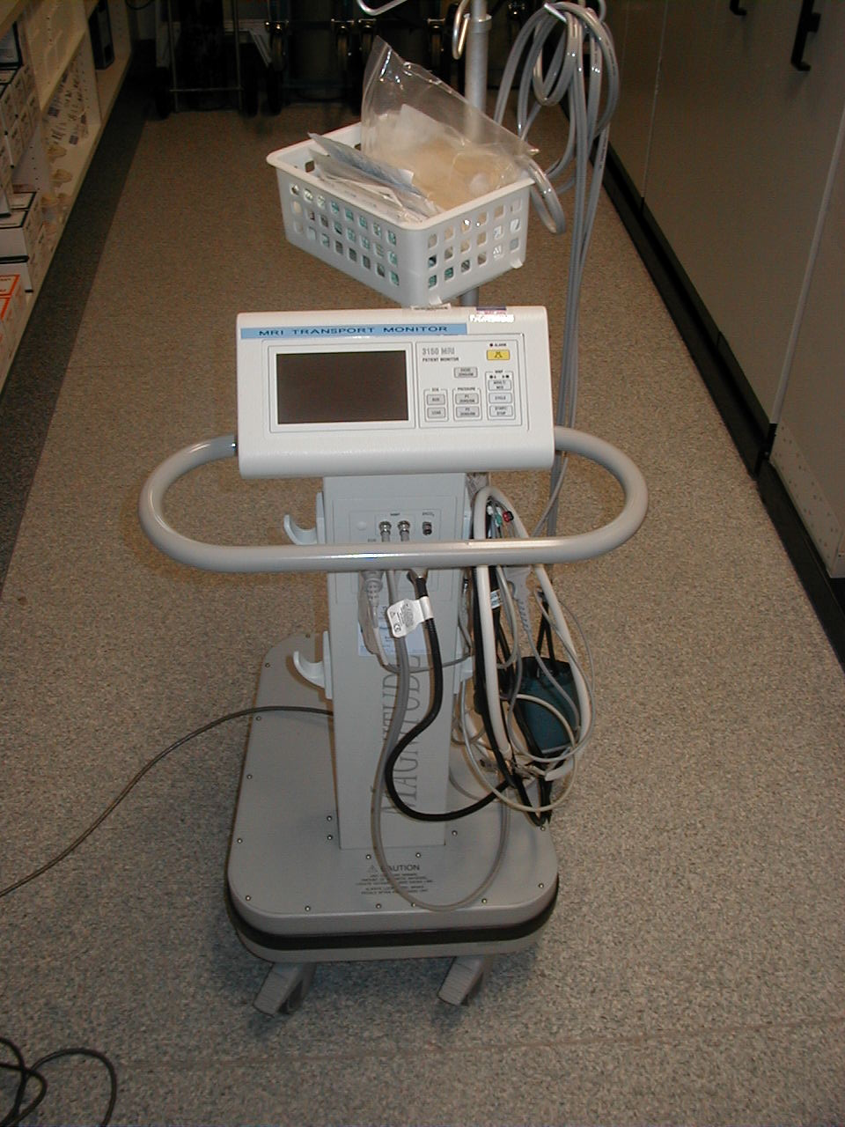Ensure that the parent unit has arranged for the patient to be admitted as a day case, rather than being done as an outpatient. This is necessary for the patient to be admitted to PACU post-op.
- The patient will not have received the usual pre-surgery instructions, so ensure that they are fasted.
- Anaesthesia in the MRI suite is a service jointly provided by the Departments of Anaesthesia and Intensive Care. The former provides an anaesthetist ± an anaesthetic nurse, drugs and airway equipment. The latter provides an MRI compatible monitor and an ICU nurse to supervise its use. It is the responsibility of the patient’s parent unit to organise the ICU input. The anaesthetist should not take on this job themselves.
MRI compatible monitor
- If you have not been in the MRI suite before you will need to complete a safety questionnaire.

Take with you:
- A regular drug trolley. Midazolam and fentanyl are available from the nurse in the MRI department.
- The MRI compatible anaesthetic machine.
- The MRI compatible monitor (or arrange to have the ICU nurse take it down).
- The “airway grab bag”, located near Hoang’s office in theatre.
- The MRI Kit Bag that includes the MRI compatible laryngoscope

Anaesthetic technique:
Almost all patients will be suitable for a spontaneously ventilating GA with a laryngeal mask. Normal laryngoscope batteries are not MRI-compatible, however the MRI compatible laryngoscope has special batteries and is able to be used in the scanner room (Warning: even the MRI compatible scope will ‘move’ to some extent in the magnetic field, so should be held onto at all times). Therefore it is preferable to induce the patient in the area outside the scanning suite in case you have to intubate. Once spontaneous ventilation on the LMA is established, move into the scanner. Note: small amounts of head movement with ventilation due to an imperfectly placed LMA will cause artefact, so be fussy with your LMA position. If you need to intubate, the MRI-compatible anaesthetic machine has an incorporated ventilator.
Have 5 lengths of minimum volume tubing connected end-to-end running from the patient’s IV line to outside the door, so that you can inject drugs from the control booth. These have a dead space of 1ml each.

Monitoring:
With the ICU MRI-compatible monitor, you can monitor ECG (which will have a lot of artefact), NIBP or invasive pressures, SpO₂, and capnography. At this stage, we do not have anaesthetic agent monitoring. The risks of awareness in a non-paralysed patient receiving volatile agents is low, as are the potential consequences of awareness given that the patient is not undergoing surgery. The master monitor stays in the scanner with the patient. The slave monitor sits, with you, outside the scanner in the control booth. If, for clinical reasons, you wish to sit in the scanning room with the patient, this is fine. The monitor employs a similar logic to the Datex monitors in theatre – i.e. a control wheel which is rotated and then pressed to confirm the selection.

Recovery:
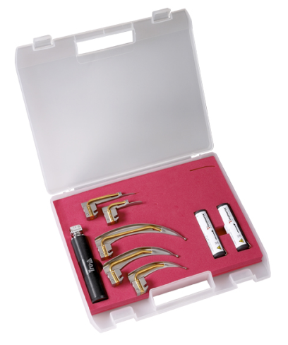
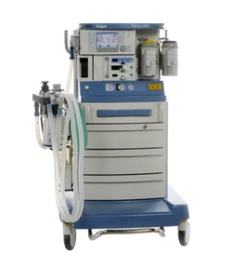
Transport the patient to main PACU after the scan. The anaesthetist will need to decide whether to allow the patient to emerge and be extubated in the MRI suite before transport, or to transport the patient anaesthetised. Either is preferable to allowing the patient to emerge en route. If the decision is to transport the patient anaesthetised, then a propofol infusion, or manually administered boluses will be required. For the transport, take with you the “airway grab bag” and whatever drugs you think you might need (or the whole drug trolley if you have an extra pair of hands).

